**Project report**

**TRAGEDY OF FLIGHT: A COMPREHENSIVE CRASH ANALYSIS**

**1.INTRODUCTION:**

**1.1. overview:**

**Flight crash analysis** is performed to determine the cause of errors once an accident has happened. In the modern aviation industry, it is also used to analyze a database of past accidents in order to prevent an accident from happening. Many models have been used not only for the accident investigation but also for educational purpose.[[1]](https://en.wikipedia.org/wiki/Aviation_accident_analysis#cite_note-:3-1)

As per the **Convention on International Civil Aviation**, also known as the **Chicago Convention**, established the [The](https://en.wikipedia.org/wiki/International_Civil_Aviation_Organization" \o "International Civil Aviation Organization)**[International Civil Aviation Organization](https://en.wikipedia.org/wiki/International_Civil_Aviation_Organization" \o "International Civil Aviation Organization)**[.](https://en.wikipedia.org/wiki/International_Civil_Aviation_Organization" \o "International Civil Aviation Organization) (ICAO), a specialized agency of the charged with united nations ordinating international air travel. The Convention establishes rules of airspace, aircraft registration and safety, security, and sustainability, and details the rights of the signatories in relation to air travel. The Convention also contains provisions pertaining to taxation.

**1.2. Human error:**

In the aviation industry, human error is the major cause of accidents. About 38% of 329 major airline crashes, 74% of 1627 commuter/air taxi crashes, and 85% of 27935 general aviation crashes were related to pilot error. The Swiss cheese model is an accident causation model which analyses the accident more from the human factor aspect.

**1.3. use of this project:**

Accident analysis is performed to determine the cause of errors once an accident has happened. In the modern aviation industry, it is used to analyse a database of past accidents in order to prevent an accident from happening.

**2 Problem Definition & Design Thinking**

**2.1 Empathy Map**

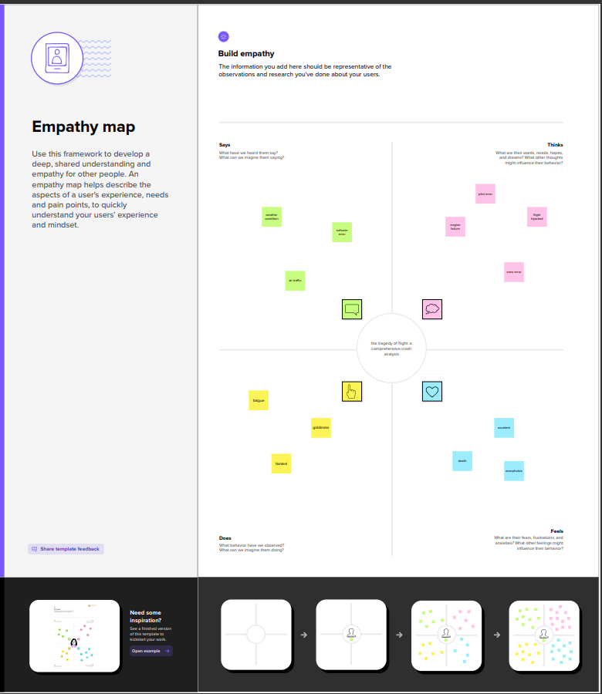

**2.2 Idealisation and Brainstorm:**

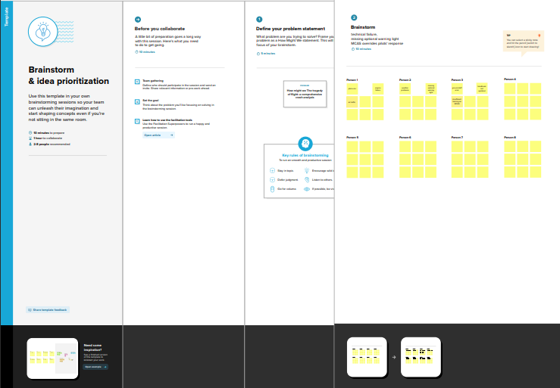

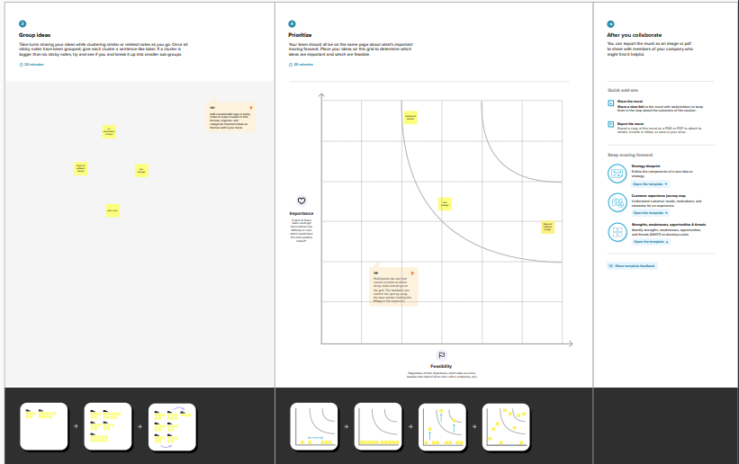

**3. Result:**

**Output of the project**

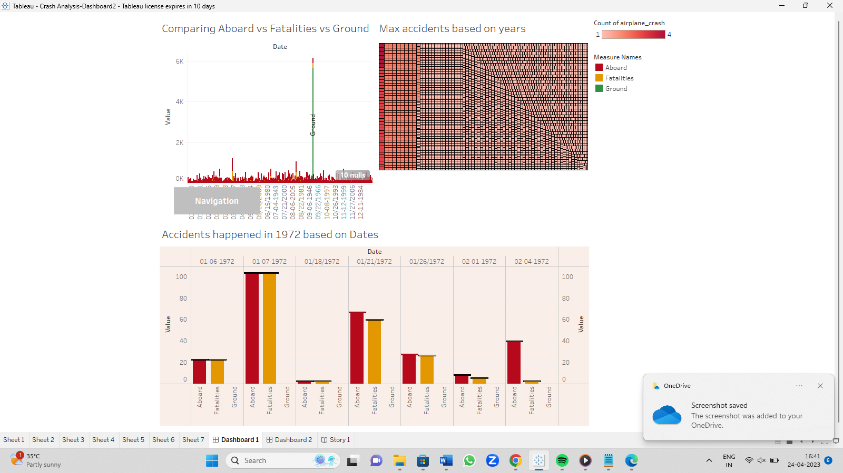

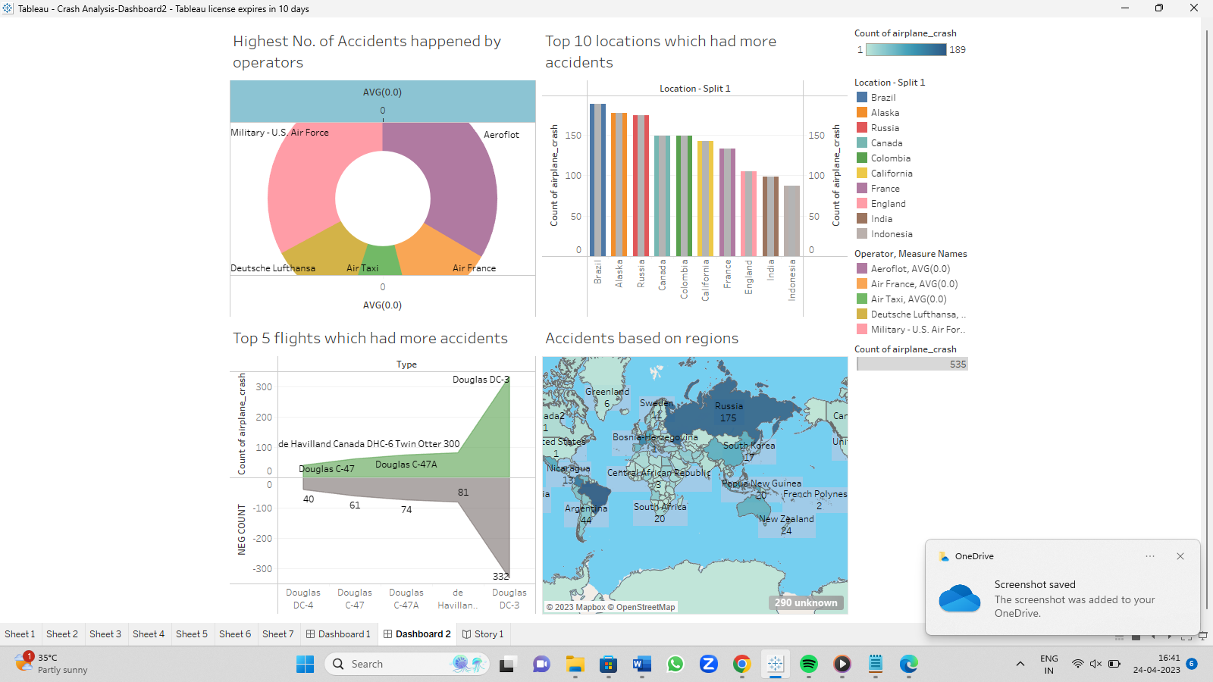

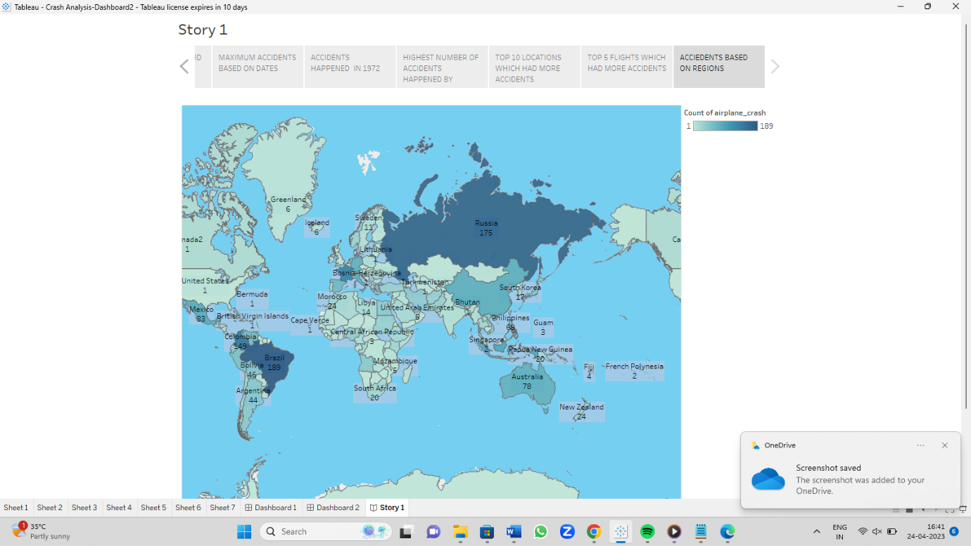

**4. Advantages and disadvantages**

Aviation accident analysis is performed to determine the cause of errors once an accident has happened. In the modern aviation industry, it is also used to analyze a database of past accidents in order to prevent an accident from happening.

To effectively discover the hazards that led to the accident and to prevent their recurrence in a future accident or incident.

**5. Airline Safety Tips**

Fly on nonstop routings. ...

Choose larger aircraft. ...

Pay attention to the pre-flight briefing.

Keep the overhead storage bin free of heavy articles.

Keep your seat belt fastened while you are seated.

Listen to the flight attendants.

Don't bring any hazardous material.

**6. conclusion**

Accident analysis is performed to determine the cause of errors once an accident has happened. In the modern aviation industry, it is used to analyse a database of past accidents in order to prevent an accident from happening.